



# A

**Project Report**

on

**Cyberbullying Detection using NLP**

submitted in partial fulfillment for the award of

BACHELOR OF TECHNOLOGY

SESSION 2023-24

In

**Computer Science and Information Technology**

Harshit Pandey

Harsh Kumar Singh

Harsh Kumar

# Under the supervision of

Mr. Ankit Kr. Saini

**KIET Group of Institutions, Ghaziabad**

Affiliated to

**Dr. A.P.J. Abdul Kalam Technical University, Lucknow**

(Formerly UPTU)

# DECLARATION

We hereby declare that this submission is our own work and that, to the best of our knowledge and belief, it contains no material previously published or written by another person nor material which to a substantial extent has been accepted for the award of any other degree or diploma of the university or other institute of higher learning, except where due acknowledgment has been made in the text.

Signature:-

Name:- Harshit Pandey

Roll No.:- 2000290110075

Date:- 29/09/2023

# CERTIFICATE

This is to certify that Project Report entitled “Cyberbullying Detection Using NLP” which is submitted by Harshit Pandey, Harsh Kumar Singh, Harsh Kumar in partial fulfillment of the requirement for the award of degree B. Tech. in Department of Computer Science and Information Technology of Dr. A.P.J. Abdul Kalam Technical University, Lucknow is a record of the candidates own work carried out by them under my supervision. The matter embodied in this report is original and has not been submitted for the award of any other degree.

.

**Date: 29/09/2023 Supervisor**

Name:- Mr. Ankit Kr. Saini

(Assistant Professor)

# ACKNOWLEDGEMENT

It gives us a great sense of pleasure to present the report of the B.Tech Project undertaken during B.Tech. Final Year. We owe special debt of gratitude to Mr./Ms./Dr. Ankit Kr. Saini Assistant Professor/ Associate Professor/ Professor, Department of Computer Science and Information Technology ,KIET, Ghaziabad, for his/her constant support and guidance throughout the course of our work. His/her sincerity, thoroughness and perseverancehave been a constant source of inspiration for us. It is only his/her cognizant efforts that our endeavors have seen light of the day.

We also take the opportunity to acknowledge the contribution of Dr. Abhinav Juneja, Head of the Department of Computer Science and Information Technology, KIET, Ghaziabad, for his full support and assistance during the development of the project. We also do not like to miss the opportunity to acknowledge the contribution of all the faculty members of the department for their kind assistance and cooperation during the development of our project.

Date : 29/09/2023

Name : Harshit Pandey Signature:

Roll No.: 2000290110075

Name : Harsh Kumar Singh Signature:

Roll No.: 2000290110071

Name : Harsh Kumar Signature:

Roll No.: 2000290110070

ABSTRACT

With the rise of the Internet, cyber bullying is becoming more and more widespread. Cyber bullying has resulted in such disastrous consequences that there is a pressing need to detect it. Many people use their social media platform to spread hate online and that is why the problem of cyber-bullying detection has been the focus of many researchers over the past decade. The aim of this study is to do the same by using Natural Language Processing (NLP) and machine learning. The target of developing such a system is to deal with Cyber Bullying that has become a prevalent occurrence on various social media.

# TABLE OF CONTENTS Page

|  |
| --- |
| DECLARATION……………………………………………………………………. 02 |
| CERTIFICATE……………………………………………………………………… 03 |
| ACKNOWLEDGEMENTS…………………………………………………………. 04 |
| ABSTRACT………………………………………………………………………..... 05 |
|  |
| CHAPTER 1 (INTRODUCTION)………………………………………………….. 07-08  CHAPTER 2 ( REQUIREMENT ANALYSIS & SYSTEM SPECIFICATION)….. 09  CHAPTER 3. (SYSTEM DESIGN)………………………………………………… 10  CHAPTER 4. (CONCLUSION AND FUTURE SCOPE)………………………….. 11  REFERENCES……………………………………………………………………… 12 |
|  |

**CHAPTER 1**

**INTRODUCTION**

* 1. **INTRODUCTION**

Bullying is an intentional, aggressive and repeated behavior that could be physical, verbal, sexual or mental. With rise of social media coupled with the Covid-19 pandemic, cyberbullying has reached all time highs. We can define cyberbullying as bullying with the use of digital technologies. It can take place on social media, messaging platforms, gaming platforms and mobile phones. It is a repeated behavior, aimed at scaring, angering or shaming those who are targeted. For example, sending hurtful, abusive or threatening messages, images or videos via messaging platforms. [1]

As social media usage becomes increasingly prevalent in every age group, most of us rely on this essential medium for our day-to-day communication. Such large usage means that cyberbullying can effectively impact anyone at anytime or anywhere and the anonymity of internet makes such attacks more difficult to stop than traditional bullying. Face-to-face bullying and cyberbullying can often happen alongside each other. But cyberbullying leaves a digital footprint – a record that can prove useful and provide evidence to help stop the abuse. [2]

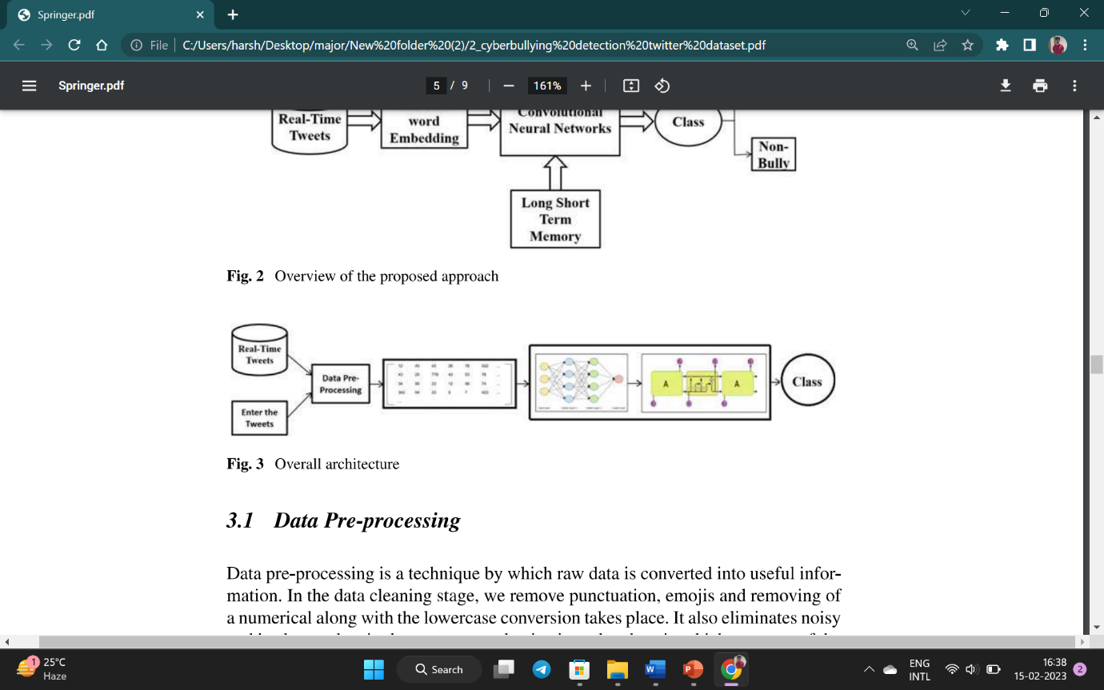

* 1. **PROJECT CATEGORY**

This project falls under the category of “Social awareness” or “anti-bullying” projects. It is a research-based project made using technologies and frameworks like python, machine learning, jupyter notebook.

In machine learning domain this project can be further classified as a supervised learning, categorical project where we perform the various machine learning steps such as data gathering , data preprocessing, feature engineering, data modelling and experimentation.

* 1. **OBJECTIVE**

On April 15th 2020, UNICEF issued a warning in response to the increased risk of cyberbullying and as per Times Of India 52,974 incidents of cyber crimes were reported in year 2021 in India. Around 85 per cent of Indian children have reported being cyberbullied as well as having cyberbullied someone else at rates well over twice the international average and nearly 8 out of 10 individuals are subject to the different types of cyberbullying in India. Out of these around 63% faced online abuses and insults, and 59% were subject to false rumours and gossips for degrading their image. [3]

Our Aim is to:-

* Create a classification model that predict cyberbullying (type & level).
* Explore words and patterns associated with each type of cyberbullying.
* Compare the work done previously in this space.

**CHAPTER 2**

**REQUIREMENT ANALYSIS AND SYSTEM SPECIFICATION**

**Software/Hardware Requirements**

1. Programming language used- Python
2. Platform used- Google Colab Notebook
3. System required- Windows 7 & above version

**Features**

|  |  |
| --- | --- |
| Feature | Priority |
| 1. Python compiler | 1 |
| 1. System with windows 7 or above operating system | 1 |
| 1. Internet Connectivity | 1 |
| 1. Google Colab Notebook | 1 |

**CHAPTER 3**

**SYSTEM DESIGN**

* For training and visualization purpose, we will use cyberbullying_tweets.csv which contains 2 features i.e. Tweet and cyberbullying_type [3]
* First, we will clean the data as per our needs such as,
  + Convert text to lower case.
  + Remove shorthands (can’t -> cannot , isn’t -> is not)
  + Normalize spaces
  + Remove special character, etc
* Then we will try to visualize and detect the pattern of tweets that are categorized as “bullying” and mark the most common words out of them which will work as Stop words for our project. [4]
* After some EDA, apply various machine learning models and pick the best model out of them.

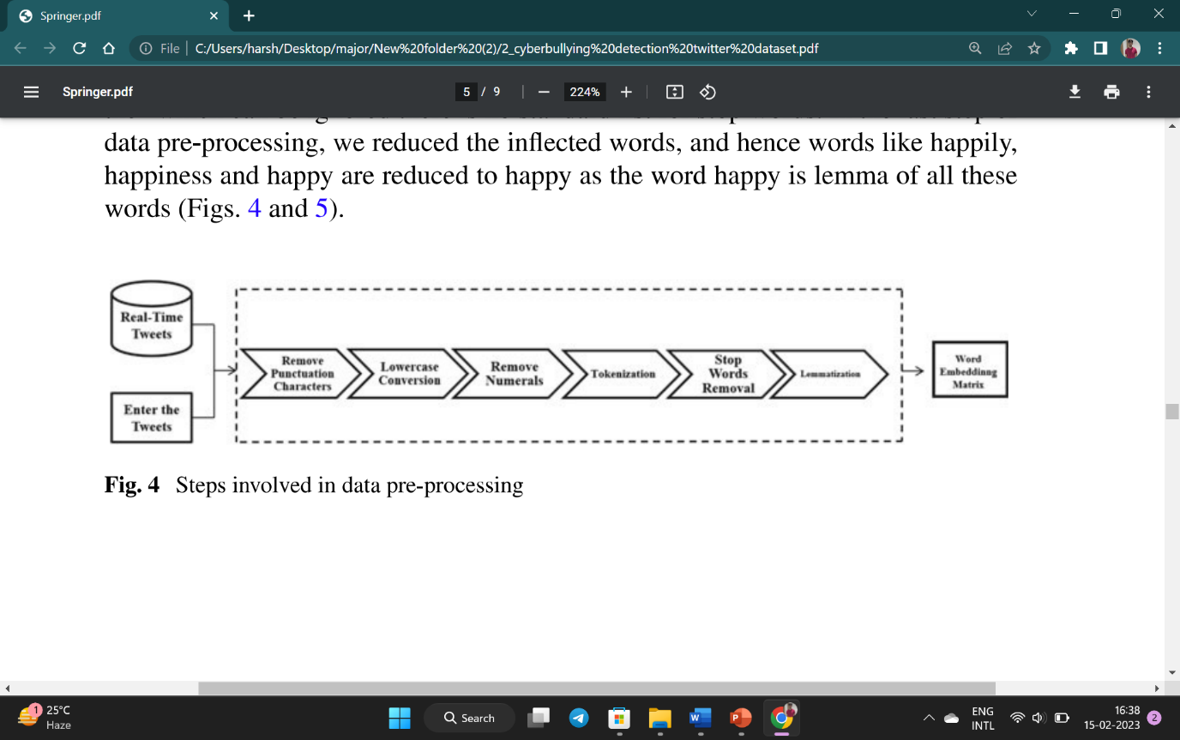

**CHAPTER 4**

**CONCLUSION AND FUTURE SCOPE**

* 1. **FUTURE SCOPE**

Social media has been on the rise since the past few years and its growth will only be augmented by internet penetration in all regions of the world. The use of this model can be extended to other social media platforms like Facebook and Instagram, which do not conform to a fixed number of characters, unlike Twitter, which is a microblog. Several possible optimizations for future works are as follows:

* Detection of cyber bullying in streaming/live data.
* Applying such classification to images and videos.
  1. **CONCLUSION**

As social media is an emerging platform to connect worldwide and easy source to attack anyone in many forms of danger like cyber bullying. Automatic detection of cyber bullying woruld enhance moderation and allow to respond quickly when necessary including different types of cyber bullying covering posts from bullies and victims. We therefore, intend to apply machine learning techniques to improve classifier performance.

**REFERENCES**

|  |  |
| --- | --- |
| [1] | I. G. A. D. Mitra Behzadi, "Rapis Cyberbullying detection methods using compact BERT Models," *IEEE,* 2021. |
| [2] | M. M. F. F. Wan Noor Hamiza Wan Ali, "Cuberbullying Detection: An Overview," *IEEE,* 2018. |
| [3] | L. Kaggle, "IEEE Bigdata," 2020. https://www.kaggle.com/datasets/andrewmvd/cyberbullying-classification. |
| [4] | K. M. L. T. Debajyoti Mukhopadhyay, "Cyber Bullying Detection Based on Twitter Dataset," *Machine Learning for predictive analysis,* no. 2021, 2020. |